Team 1
DATS 6103: Summary Report
Professor Ning Rui
30/4/25
Food Deserts in the United States

Introduction
Food deserts are communities where residents have limited access to affordable and nutritious food, particularly fresh fruits and vegetables. These areas are often defined by their lack of supermarkets or grocery stores within convenient traveling distance and typically overlap with low-income or marginalized populations. According to the USDA, food deserts are identified as census tracts meeting both low-income and low-access criteria.
Our research was motivated by the critical public health and social equity implications of food deserts. Millions of Americans—especially those living in rural regions, minority communities, or impoverished neighbourhoods—struggle to access essential nutrition, which may contribute to broader systemic issues including chronic health problems, economic stagnation, and intergenerational poverty.
This project aimed to use data-driven methods to explore the geographic patterns, contributing factors, and potential policy interventions related to food deserts in the United States. Through exploratory data analysis (EDA), statistical modeling, and predictive analytics, our team sought to understand the root causes and potential solutions to this pressing issue.

Why We Chose This Topic
The topic of food deserts resonated with our team due to its intersectional nature—it touches upon socioeconomic inequality, public health, urban and rural development, transportation infrastructure, and nutrition education. Given the increased awareness of health disparities during the COVID-19 pandemic, we saw an opportunity to use data science tools to provide insights that could support more equitable food systems across the U.S.
Food security is a fundamental determinant of health and well-being, and addressing food deserts requires a multidisciplinary approach. We were especially interested in exploring how machine learning and statistical models could not only reveal trends but also inform actionable policies.

Literature Review and Background Research
Prior research has shown that food deserts are more prevalent in areas with high poverty, low vehicle ownership, and limited access to transportation. Studies have documented the link between food access and diet-related health outcomes, although the strength of this relationship varies by region and demographic group. Some researchers argue that physical proximity to food is only part of the problem—affordability, cultural preferences, and education also play key roles.
For instance, Ver Ploeg et al. (2009) in a USDA report highlighted that while low-income communities often lack large grocery stores, they may still have small corner stores that offer limited or unhealthy food options. Other studies, such as those by Walker et al. (2010), have shown that the presence of food deserts correlates with increased prevalence of obesity and Type 2 diabetes, but access alone does not guarantee improved health outcomes.
Our project builds on these findings by integrating datasets across health, economic, and demographic dimensions to assess both the presence and the effects of food deserts.

Description of the Data
We utilized and merged several public datasets:
- USDA Food Access Research Atlas – Provided tract-level indicators of food access based on income and distance to supermarkets.
- American Community Survey (ACS) – Supplied demographic and economic variables such as income, poverty rate, race/ethnicity, and education.
- CDC 500 Cities and County Health Rankings – Contained county-level health indicators such as obesity and diabetes prevalence.
- SNAP Participation and Vehicle Ownership – These datasets offered insight into the economic hardship and infrastructure challenges of communities.
All data were joined using CountyFIPS codes or census tract identifiers to ensure geographic consistency. Data preprocessing included handling missing values, normalizing variables, and categorizing urban vs. rural tracts based on USDA designations.

Exploratory Data Analysis (EDA)

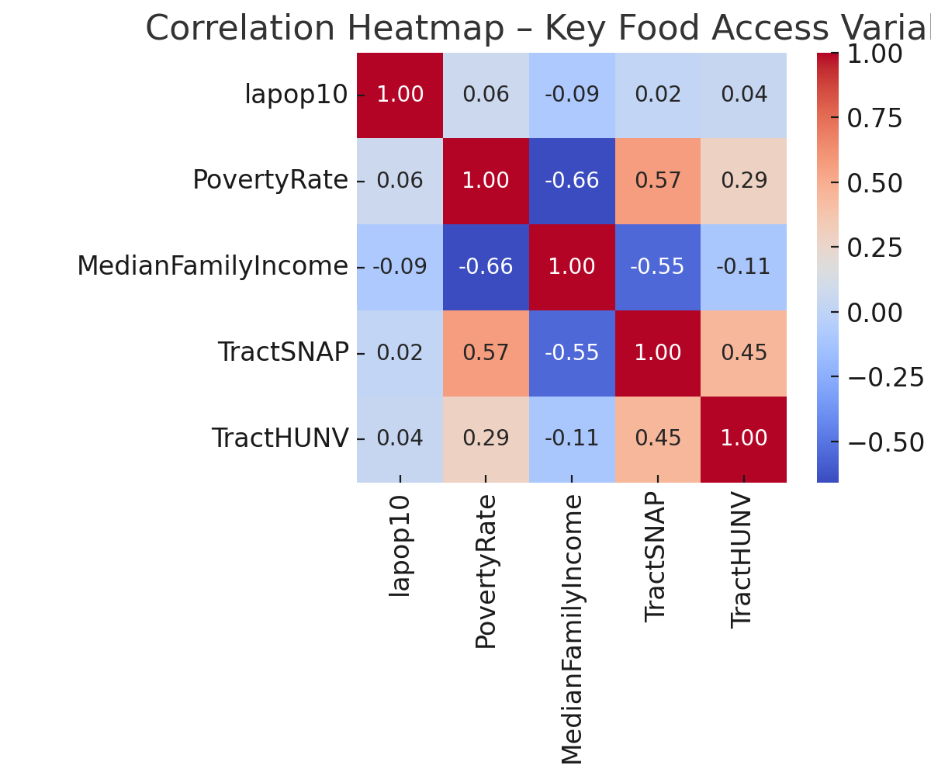
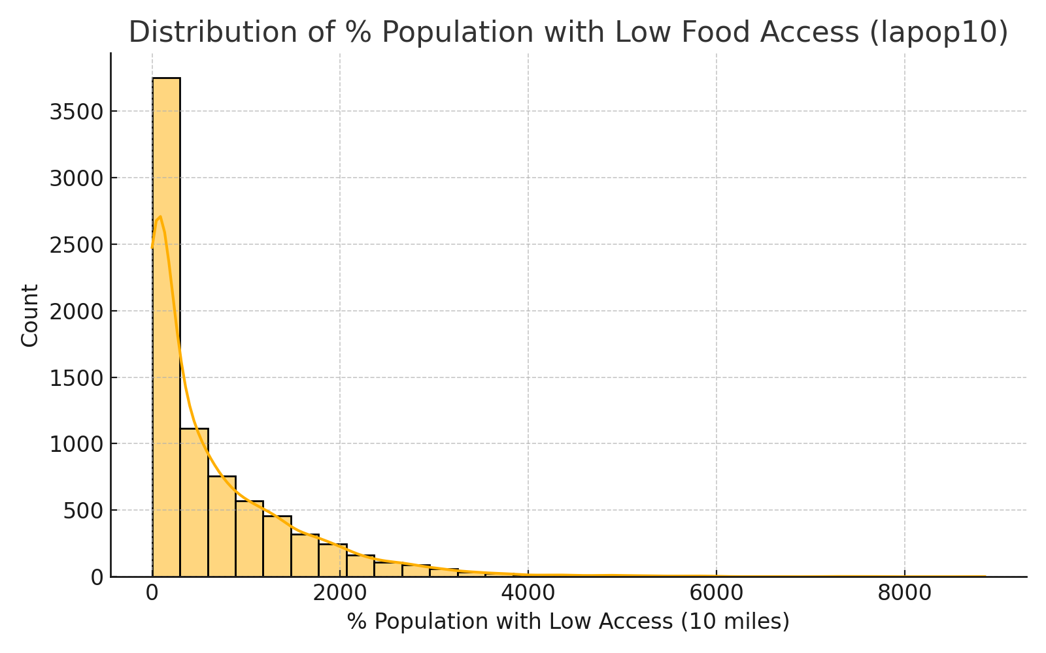

We began our analysis with a comprehensive EDA to understand where food deserts are most prevalent and what characteristics define them.
Geographic Distribution
Our spatial analysis showed clear regional trends:
- Texas has the highest number of food desert tracts, largely due to its size and number of rural counties.
- Mississippi has the highest proportion of food desert tracts relative to total tracts in the state.
- Urban food deserts are concentrated in southeastern states such as Alabama, Mississippi, and Arkansas.
- Rural food deserts dominate in the Southwest (e.g., Arizona, New Mexico) and Alaska, often with large distances between food sources.
[Insert visual: U.S. map of food desert concentrations from slide]
This distribution highlights the varying nature of food insecurity across rural and urban landscapes and underscores the importance of region-specific interventions.

Socioeconomic and Demographic Factors
We generated a correlation matrix using key demographic and economic indicators. Notable findings include:
- Strong positive correlation between food desert status and:
  - Poverty Rate
  - SNAP Participation
  - Lack of Vehicle Access
- Moderate correlation with:
  - Median Family Income (negative)
  - Education level
  - Minority population percentage
[Insert visual: Correlation heatmap from slide]
These correlations confirm that food deserts are tightly linked to broader socioeconomic hardship. Importantly, the presence of a supermarket is not enough—household income, transportation access, and social safety net participation all affect a community’s food security.

SMART Questions & Insights
Q1: Where are food deserts most geographically concentrated across the U.S.?
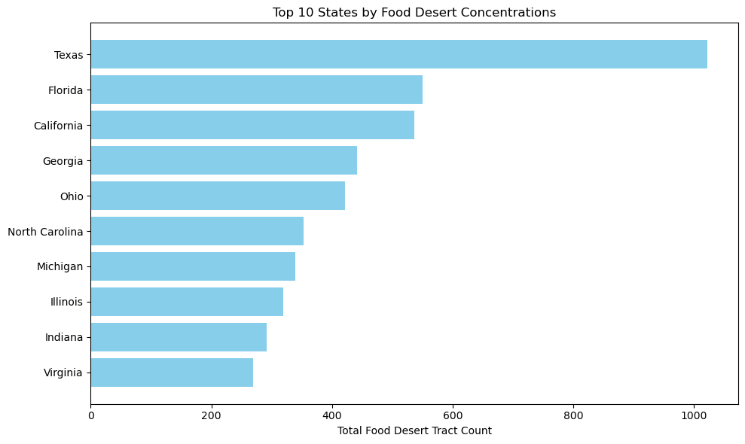

We used tract-level USDA data to identify hotspots of food insecurity. As mentioned, southeastern and southwestern states have the greatest concentrations, with rural tracts generally more affected in terms of physical access and urban tracts more affected in terms of density.
This spatial distribution is likely influenced by factors such as:
- Urban sprawl and zoning in cities
- Lack of commercial incentives in rural markets
- Poor infrastructure and limited transportation
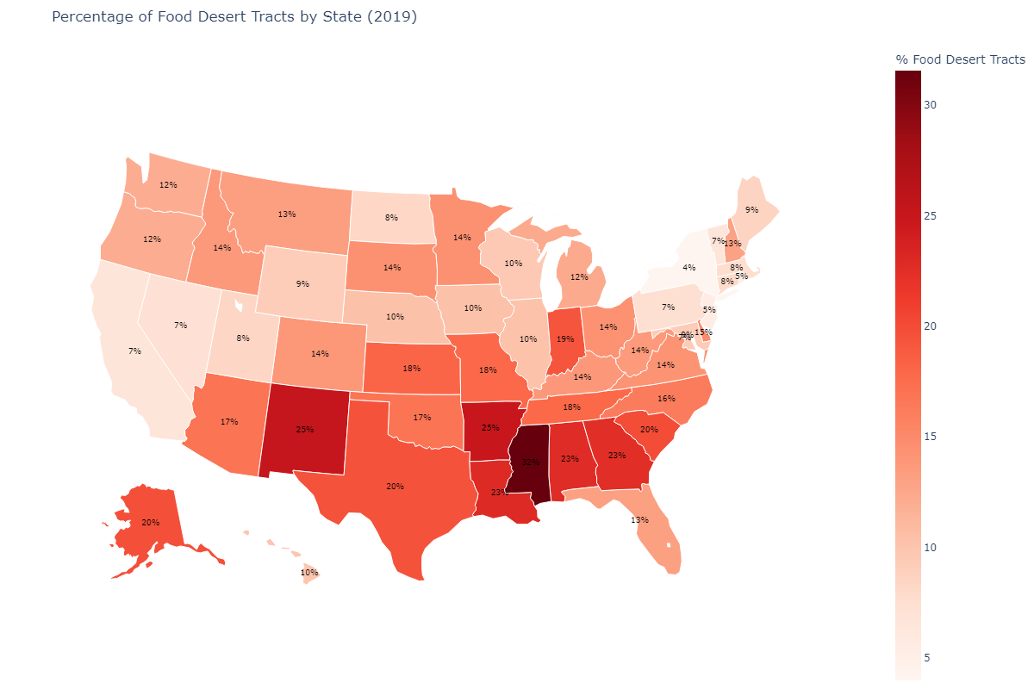

Q2: What demographics and socioeconomic factors are linked to food deserts?
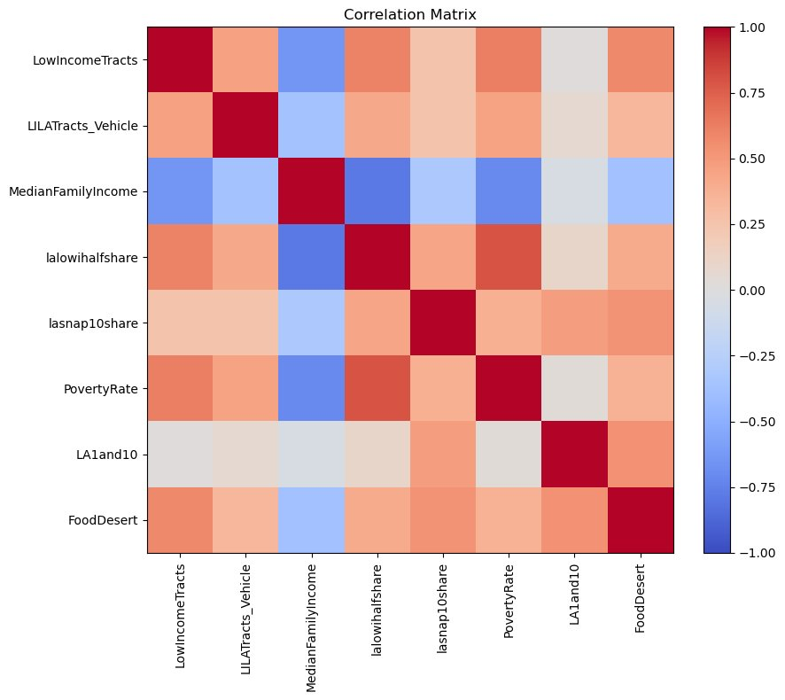
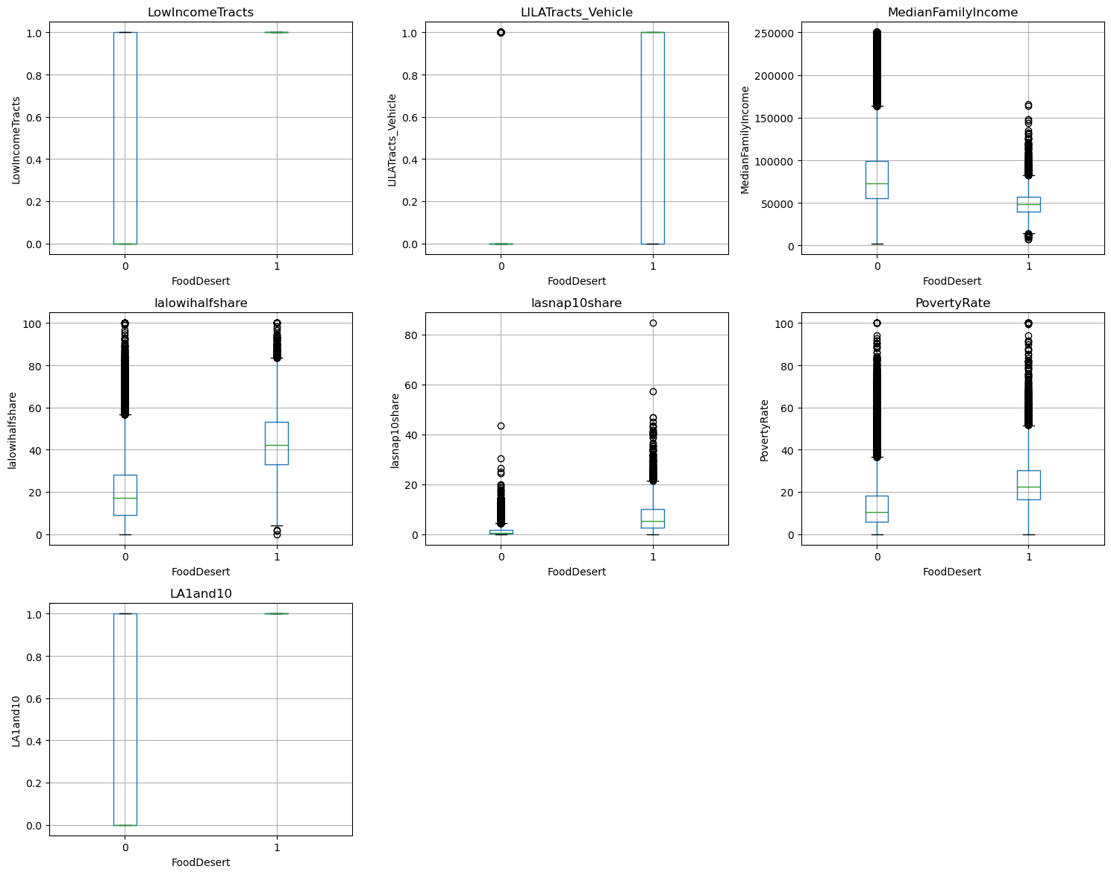
Key variables associated with food deserts include:
- Low income status
- Limited vehicle access
- High unemployment
- High SNAP dependency
- Lower educational attainment
These indicators suggest that food insecurity stems from structural inequality, not just poor planning. Households may technically live within a mile of a grocery store, but without a car or reliable public transport, access remains a barrier.

Q3: How are food deserts related to health issues like obesity and diabetes?
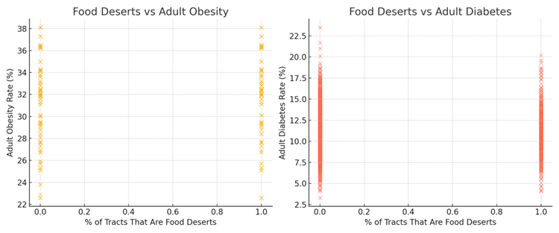

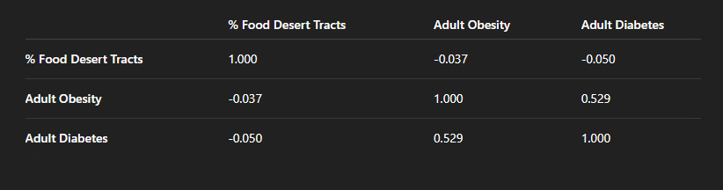
We merged tract-level health data with food desert indicators. Our analysis found:
- A weak correlation between food desert status and obesity/diabetes rates
- A strong correlation (r ≈ 0.53) between obesity and diabetes themselves
[Insert visual: Health outcome correlation table]
This suggests that food deserts may contribute to poor health, but they are not the sole driver. Other influences—such as healthcare access, exercise opportunities, cultural diet patterns, and education—must also be considered.

Q4: Can we develop a predictive model that identifies high-risk areas?
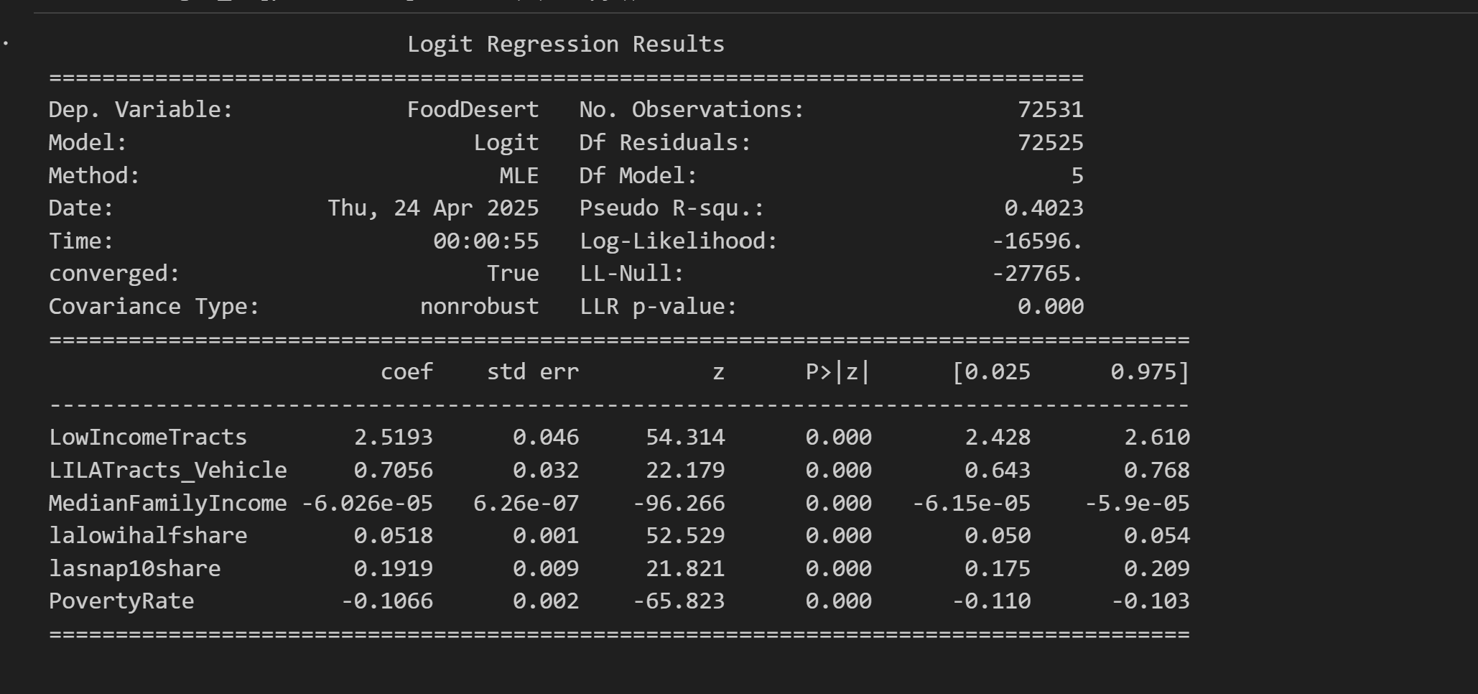

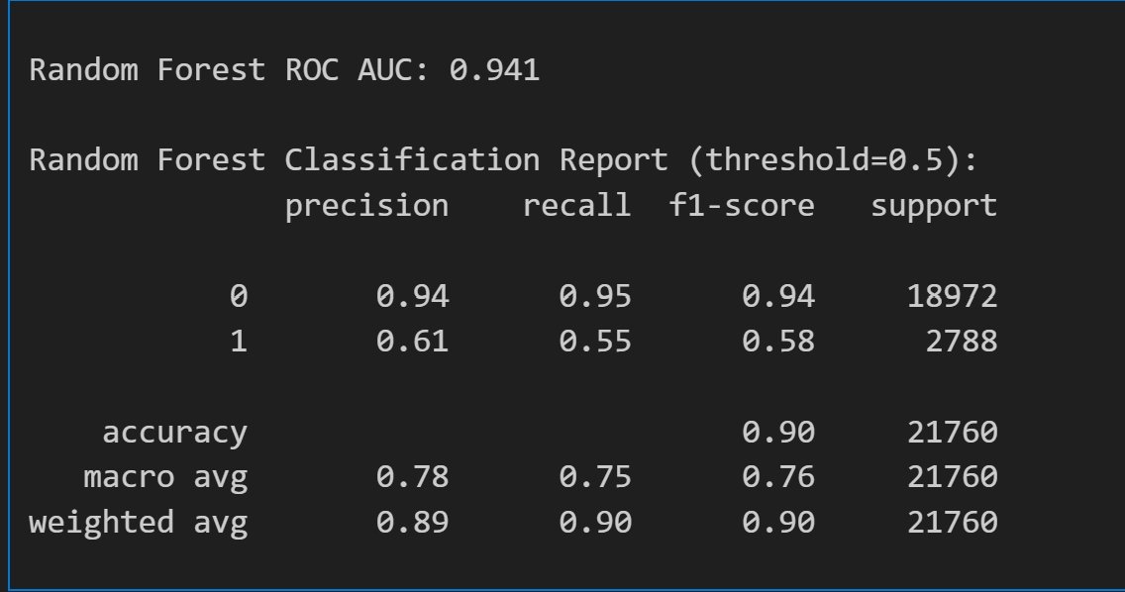
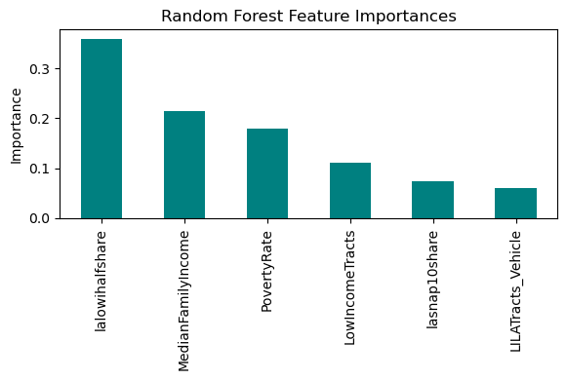

We constructed two predictive models:
- Logistic Regression – Provided interpretable coefficients for each variable.
- Random Forest – Offered higher performance and ranked feature importance.
Logistic Regression Highlights:
- Poverty rate, SNAP participation, and low vehicle access were statistically significant.
- Model accuracy was moderate, but interpretability was strong.
Random Forest Metrics:
- Higher accuracy and AUC.
- Top features included:
  - SNAP Participation
  - Poverty Rate
  - Vehicle Access
  - Median Family Income
[Insert visuals: Logit summary and RF feature importance from slides]
The models performed well in classifying food desert tracts and could be adapted by policymakers to target at-risk areas more proactively.

Q5: What national policies could reduce food deserts?

Our results point to multiple intervention opportunities:
- SNAP expansion: Increase funding, broaden eligibility, and promote acceptance at more retail locations.
- Transportation improvements: Invest in public transit and infrastructure in low-access areas.
- Incentives for local grocers: Offer tax breaks or subsidies to encourage stores to open in underserved communities.
- Nutrition education programs: Combine access initiatives with awareness campaigns.
- Support for local agriculture: Encourage farmers’ markets and community-supported agriculture in urban and rural areas.
These interventions should be multi-tiered, combining federal, state, and local efforts and tailored to regional needs.

Conclusions
Our analysis confirms that food deserts are complex, multifactorial problems rooted in geography, infrastructure, and inequality. While physical distance to food sources matters, our findings emphasize that income, transportation, and economic vulnerability are stronger predictors of food insecurity.
Health impacts are not directly caused by food deserts alone, but they are amplified by the intersecting disadvantages that accompany them. Thus, any solution must address the full ecosystem—access, affordability, education, and opportunity.
Our predictive models offer a foundation for targeted policy responses and further research. By identifying high-risk areas with precision, we can improve resource allocation and advance equitable access to nutrition for all Americans.

Limitations and Future Directions
Some limitations of our study include:
- Health data was at the county level, while food desert classification was tract-level, leading to some granularity mismatch.
- Not all relevant variables were available—future research should integrate factors like crime rates, school quality, and walkability.
- Our models assume static conditions; longitudinal data could better capture the dynamics of changing neighbourhoods.
Future directions include:
- Incorporating geospatial clustering and time-series analysis.
- Analyzing interventions and their outcomes over time.
- Collaborating with urban planners, public health departments, and non-profits for real-world applications.

References

